Revision Human Biology Respiratory System and Cardiovascular System

Where does the exchanges of fluid, nutrients and wastes between the blood and the tissues occur? ______________
What are the functions of the valves in the heart? Describe the difference between the “lub” and the “dup” of the heart (hint: describe what which valves are involved for which sound and which sound comes first)
_______________________________________________________________________________________________
_______________________________________________________________________________________________
_______________________________________________________________________________________________
_______________________________________________________________________________________________
_______________________________________________________________________________________________

Draw a diagram of an alveolus and a capillary that surrounds it.
Label the diagram and show the flow of blood and describe
the colour change in the blood as it flows from one side of the
alveolus to the other

How does blood carry carbon dioxide? _______________________________________________________________
How does blood carry oxygen? _____________________________________________________________________
Describe the functions of platelets __________________________________________________________________
Name the different parts in the blood and describe their appearance and their function _______________________________________________________________________________________________
_______________________________________________________________________________________________
_______________________________________________________________________________________________
_______________________________________________________________________________________________
_______________________________________________________________________________________________
_______________________________________________________________________________________________
_______________________________________________________________________________________________
_______________________________________________________________________________________________
_______________________________________________________________________________________________
What is systole and diastole? ______________________________________________________________________
_______________________________________________________________________________________________
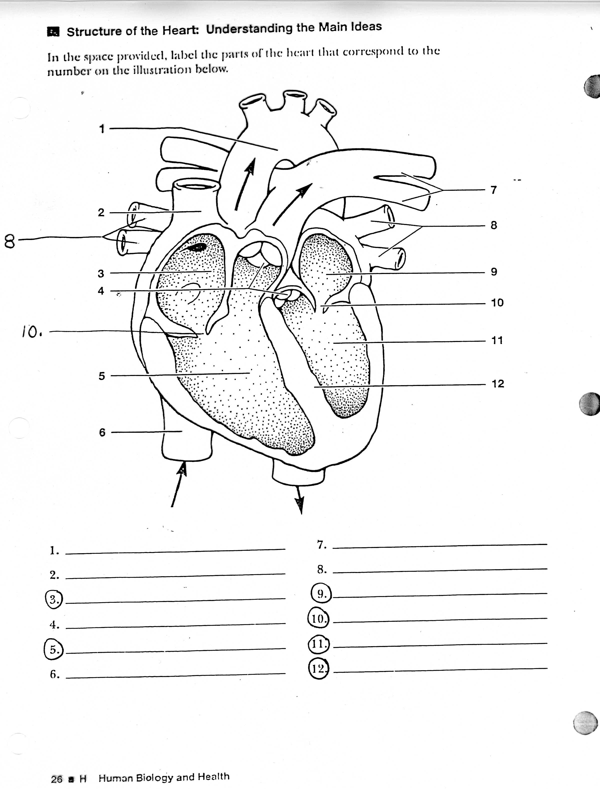
Label the heart and describe the functions of each.
Describe the function of the tendinous cords attached to the atrioventricular valves and the heart wall
____________________________________________
____________________________________________
____________________________________________
____________________________________________
____________________________________________
____________________________________________
____________________________________________
____________________________________________
____________________________________________
____________________________________________
____________________________________________
____________________________________________
____________________________________________
____________________________________________
Name the membranes that cover the heart and lungs
_______________________________________________________________________________________________

Describe inspiration and expiration
_______________________________________________________________________________________________
_______________________________________________________________________________________________
_______________________________________________________________________________________________
_______________________________________________________________________________________________

Describe how blood is pumped around the heart, lungs and body, include the chambers of the heart
_______________________________________________________________________________________________
_______________________________________________________________________________________________
_______________________________________________________________________________________________
_______________________________________________________________________________________________
_______________________________________________________________________________________________
Draw and label the tissues of an artery, a vein and a capillary and describe the function of each vessel

_______________________________________________________________________________________________
_______________________________________________________________________________________________
_______________________________________________________________________________________________
_______________________________________________________________________________________________
_______________________________________________________________________________________________

Describe how parts of the lungs assist in the exchange of gases
_______________________________________________________________________________________________
_______________________________________________________________________________________________
_______________________________________________________________________________________________
_______________________________________________________________________________________________
_______________________________________________________________________________________________
_______________________________________________________________________________________________
_______________________________________________________________________________________________
_______________________________________________________________________________________________
_______________________________________________________________________________________________
_______________________________________________________________________________________________
_______________________________________________________________________________________________
_______________________________________________________________________________________________
_______________________________________________________________________________________________
_______________________________________________________________________________________________
_______________________________________________________________________________________________
_______________________________________________________________________________________________
_______________________________________________________________________________________________
_______________________________________________________________________________________________
_______________________________________________________________________________________________
_______________________________________________________________________________________________

